جامعة المنوفية
كلية الحاسبات والمعلومات
2024-2025
Menofyia University
System Analysis & design Project
second year
2024-2025


No. | Name | Section
1 | Seif Abdelhakeem Salem Hegazy | 3
2 | Mohamed Hussein Sobhy Elbadry | 3
3 |  | 4
4 |  | 5
5 |  | 7
6

العنوان

Planning (Project Plan)

Project Identification
Project Name:
Expense Tracker System

Current Problem:
- Difficulty in tracking daily and monthly expenses manually or using paper records.
- Lack of clear and organized expense categories (e.g., bills, food, entertainment, transportation).
- Difficulty in knowing where the salary or available money goes by the end of the month due to the absence of reports and statistics.
- Possibility of losing paper budget records or making manual calculation errors

Description about project:
* The system is a web-based application that allows users to easily track their expenses and income by entering transactions and classifying them into specific budget categories.
* The system helps users set a specific budget for each category and alerts them when it is exceeded.
* It enables users to generate accurate reports and statistics, as well as visual charts showing cash flow, which reduces effort and time, prevents calculation errors, and helps in making better financial decisions

System Request
System Request—library System
Project Sponsor: | Project Management / Target Users
Business Need: | control personal expenses  provide accurate  quick financial reports to avoid financial crises.
Business Requirements:
Business Value: | 1- Providing accurate and immediate financial information.  2- Saving time and effort in manual calculations.  3- Lowering costs and managing savings more effectively.  4- Making conscious financial decisions based on reliable reports.
Special Issues or Constraints: | 1- Strict deadline for project delivery.  2- Ensuring the security and privacy of users' financial data with continuous system updates.

Feasibility Analysis
Technical Feasibility
1- We need to design the user interface using HTML, CSS, and JavaScript.
2- We need development environments and tools such as Visual Studio Code.
3- We need the system to work online when connected to the internet (Web-based application).
4- We need this website to be compatible with standard operating systems and browsers across Windows and mobile devices.

Economic Feasibility
1- The financial benefits of this project will be high and acceptable.
2- The potential losses or risks are minimal and mostly limited to initial development time.
3- The only requirement for full access is secure user authentication.
4- The development cost will be low since most tools and frameworks are open-source or free.

Organizational Feasibility
Organizational Feasibility Analysis includes the assessment of:
- Management prowess: what is the ability of the initial management team?
- Resource sufficiency: what nonfinancial resources such as human resources (management, employees), facilities/location, equipment, intellectual property protection, etc. are required?

Time Estimation

 | Planning | Analysis | Design | Implementation
Standard percentages | 15% | 20% | 35% | 30%
Estimated time based on planning time | Actual: 11 days | 16 days | 25 days | 22 days

Tasks Identification
System Request | Name of Task
9/11/2026 | Start Date
12/11/2026 | End Date
Joulnar Hussein, rawan | Person assigned to task
High | Priority
Microsoft word | Resources Needed
4 hours | Estimated Time
2hours | Actual Time

Feasibility Study | Name of Task
12/11/2026 | Start Date
17/11/2026 | End Date
Ahmed mahmoud | Person assigned to task
High | Priority
Microsoft word | Resources Needed
8 hours | Estimated Time
5 hours | Actual Time

Pert Chart, Grantt Chart | Name of Task
17/11/2026 | Start Date
19/11/2026 | End Date
Ali raafat | Person assigned to task
High | Priority
Ms project | Resources Needed
9 hours | Estimated Time
6 hours | Actual Time

Interview | Name of Task
19/11/2026 | Start Date
24/11/2026 | End Date
Joulnar Hussein, rawan | Person assigned to task
Medium | Priority
Microsoft word | Resources Needed
16 hours | Estimated Time
14 hours | Actual Time

Questionnaire | Name of Task
19/11/2026 | Start Date
23/11/2026 | End Date
Ahmed allam | Person assigned to task
Medium | Priority
Form drive | Resources Needed
5 hours | Estimated Time
2 hours | Actual Time

Data Flow Diagram | Name of Task
24/11/2026 | Start Date
29/11/2026 | End Date
Ahmed Mahmoud, Ahmed allam | Person assigned to task
High | Priority
Internet | Resources Needed
1 day | Estimated Time
18 hours | Actual Time

Data Store | Name of Task
29/11/2026 | Start Date
2/12/2026 | End Date
Ahmed mahmoud | Person assigned to task
High | Priority
Microsoft word | Resources Needed
1 day | Estimated Time
17 hours | Actual Time

process specification | Name of Task
29/11/2026 | Start Date
3/12/2026 | End Date
Joulnar hussein | Person assigned to task
High | Priority
Microsoft word | Resources Needed
1 day and 10 hours | Estimated Time
19 hours | Actual Time

Entity Relationship | Name of Task
2/12/2026 | Start Date
6/12/2026 | End Date
Rawan | Person assigned to task
High | Priority
StarUML | Resources Needed
1 day and 10 hours | Estimated Time
19 hours | Actual Time

Normalization | Name of Task
2/12/2026 | Start Date
6/12/2026 | End Date
ali raafat | Person assigned to task
High | Priority
StarUML | Resources Needed
1 day and 10 hours | Estimated Time
19 hours | Actual Time

design | Name of Task
7/12/2026 | Start Date
2/1/2027 | End Date
- | Person assigned to task
High | Priority
Visual studio code | Resources Needed
18 days | Estimated Time
13 days | Actual Time

Implementation | Name of Task
2/1/2027 | Start Date
24/1/2027 | End Date
Ahmed allam ,ali raafat | Person assigned to task
High | Priority
Visual studio code | Resources Needed
16 days | Estimated Time
11 days | Actual Time

Pert Chart (MS-Project)
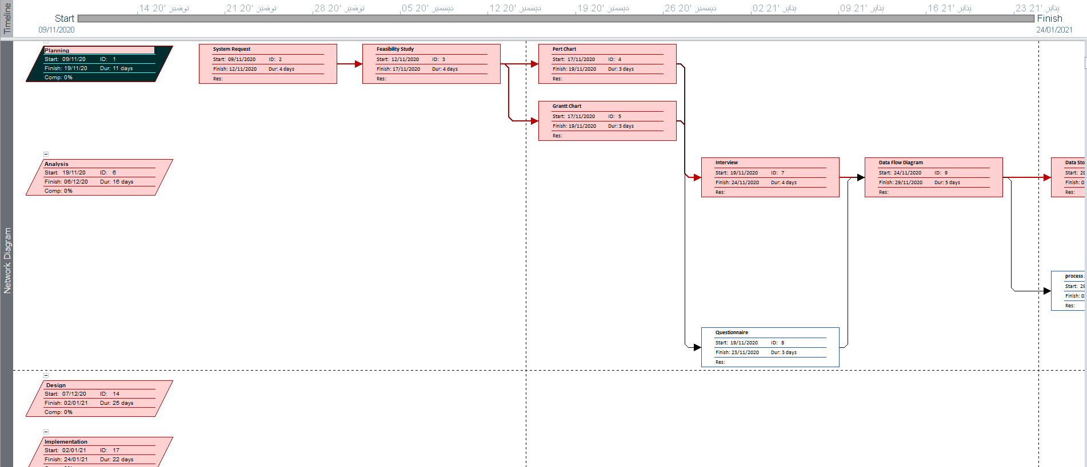

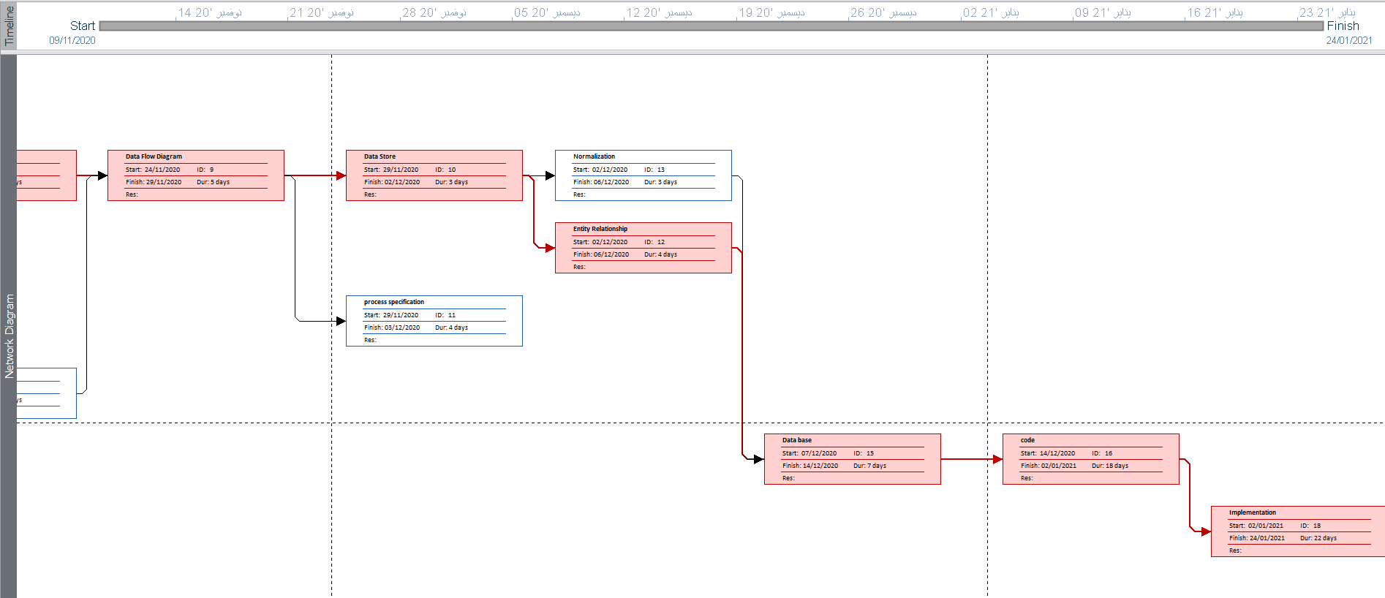

Gantt chart (MS-Project)

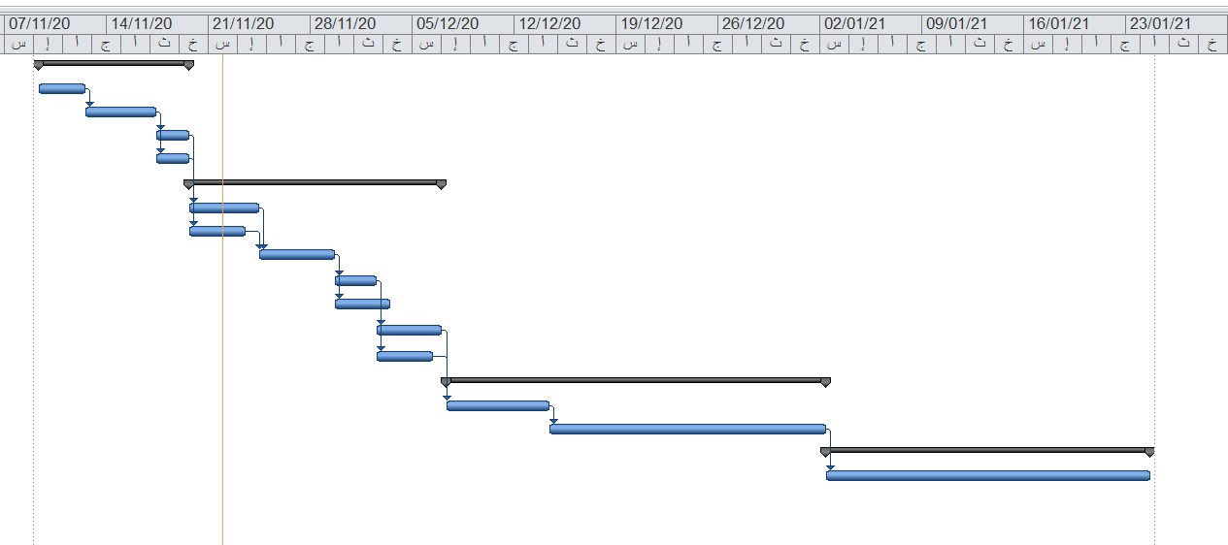

Analysis (Project Proposal)

Interview
(include questions and answers)
- How do you currently record and track your daily expenses?
I usually write some expenses in my phone notes, but I sometimes forget to record small purchases.
- What are the biggest problems you face when managing your money ?
It is difficult to remember where my money went and to understand which categories cost me the most.
- Which expense categories would be most useful for you to track?
Food, transportation, bills, shopping, education, and entertainment.

- What reports or summaries would help you understand your spending?

A monthly summary, category totals, and a comparison between this month and last month.

- What features would make an expense tracker easy and useful for you?

Quick expense entry, a simple interface, search and filtering, budgets, and reminders

- Do you currently use an application to track your expenses?
No
- Would you like the system to let you set a monthly budget?

Yes

- Do you need to categorize each expense?
Yes

- Would you like to view reports by week and month?
Yes

- Would you use the system regularly if adding an expense took less than a minute?
Yes

- What is the main reason you want to use an expense tracker?
I want to control my spending and avoid running out of money before the end of the month.
- Which additional feature would you like the system to include?
I would like recurring expense reminders and an option to export reports.
- Describe a recent difficulty you had when trying to understand your spending.
I could not tell how much I had spent on food because the transactions were spread across different notes.
- How would you prefer to view your spending information?
I prefer a dashboard with charts and a clear monthly total.
- What suggestions do you have to improve the proposed Expense Tracker System?
Make it easy to use on a mobile phone and allow users to edit or delete incorrect entries
- Which device would you mainly use? (Mobile / Laptop or desktop / Tablet)
Mobile
- Would you like to create an account and sign in securely? (Yes / No)
Yes
- Should the system support monthly budgets? (Yes / No)
Yes
- Would you like to receive a warning when you approach your budget limit? (Yes / No)
Yes
- How often would you expect to review your expenses? (Daily / Weekly / Monthly / Rarely)
Weekly

Interview Reports
Interview Report
Person Interviewed: Mr. Ahmed
Interviewer: Ahmed Allam
Purpose of Interview:
1. To see how the system works with it
2. Take advantage of its system and address errors
3. Knowing some of the system tools and how they will be developed
Summary of Interview:
- The system work to show some free books in a website
- Common error is Loss of copyright to the authors
- He use Low security system
Open Items:
- 1- Minimum 6 employees in one section.
- 2- Create an application mobile to make the purchase process fast for the customer.
- 3- Create a website page to make buying online easy to the user.
Detailed Notes: See attached transcript.

Interview Report
Person Interviewed: mr ali
Interviewer: ahmed
Purpose of Interview:
1. To see how the system works with it
2. Take advantage of its system and address errors
3. Knowing some of the system tools and how they will be developed
Summary of Interview:
- The system is a website can find the book that you want easily by entering the code or the name of the book, it enables the user to borrow any book he want
- Accessing your large books and adding them on website
- Make page on website for user registration
- Make page to Add a lot of books Not free
Open Items:
- 1- Minimum 6 employees in one section.
- 2- Create an application mobile to make the purchase process fast for the customer.
- 3- Create a website page to make buying online easy to the user.
Detailed Notes: See attached transcript.

Interview Report
Person Interviewed: eng mohamed
Interviewer: ahmed
Purpose of Interview:
1. To see how the system works with it
2. Take advantage of its system and address errors
3. Knowing some of the system tools and how they will be developed
Summary of Interview:
- The system library contains all types of books in different fields and is a website.
- Common error is Loss of copyright to the authors
- Use multiple payment methods
Open Items:
- 1- Minimum 6 employees in one section.
- 2- Create an application mobile to make the purchase process fast for the customer.
- 3- Create a website page to make buying online easy to the user.
Detailed Notes: See attached transcript.

Questionnaire & RESPONSES
(using Google Forms, you must include questions and statistics)
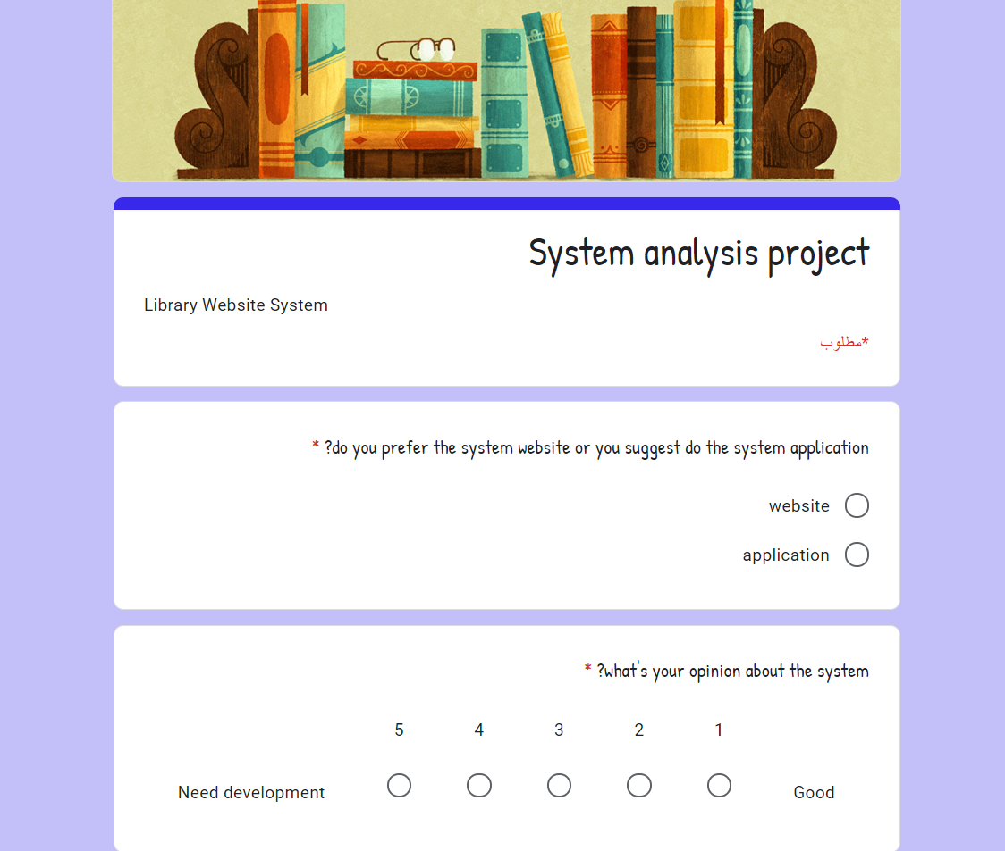
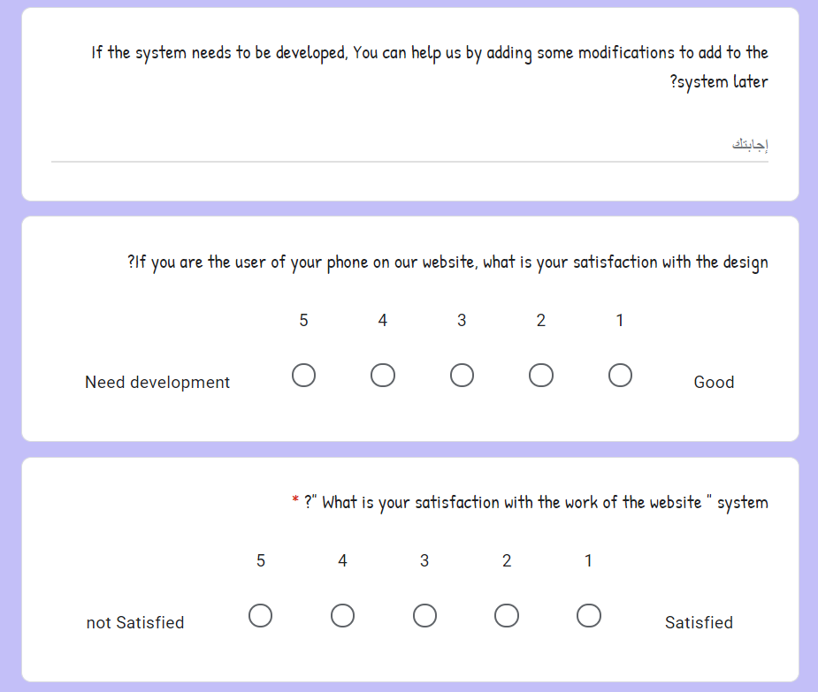

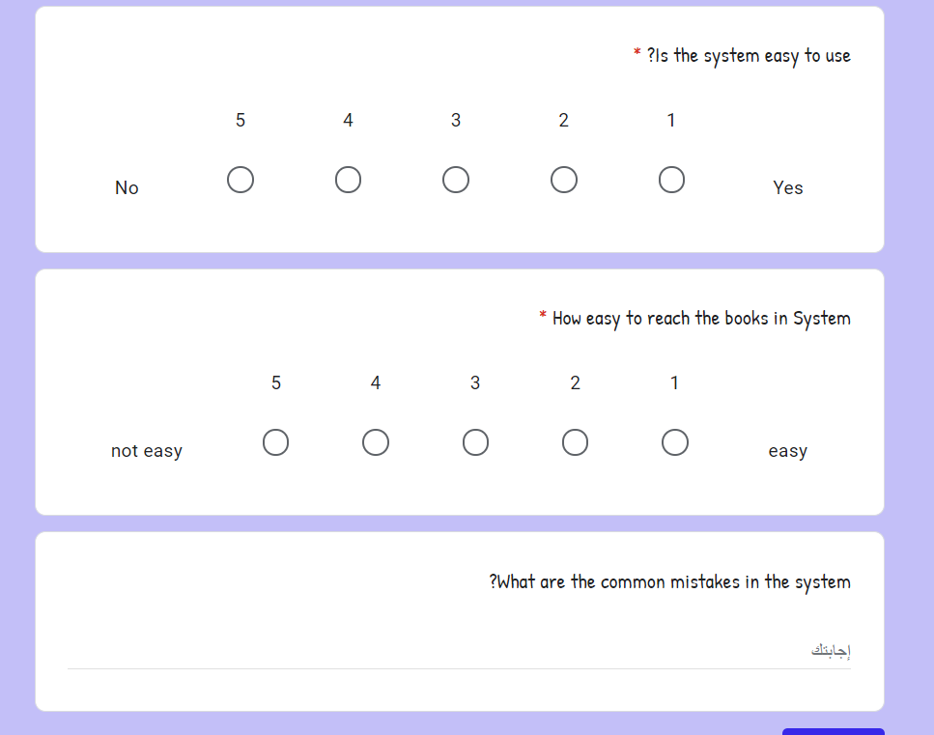
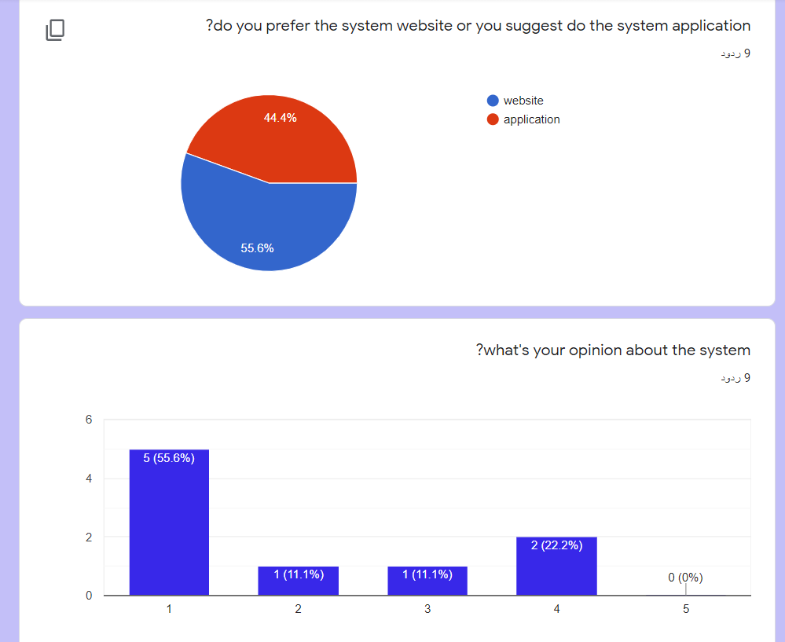
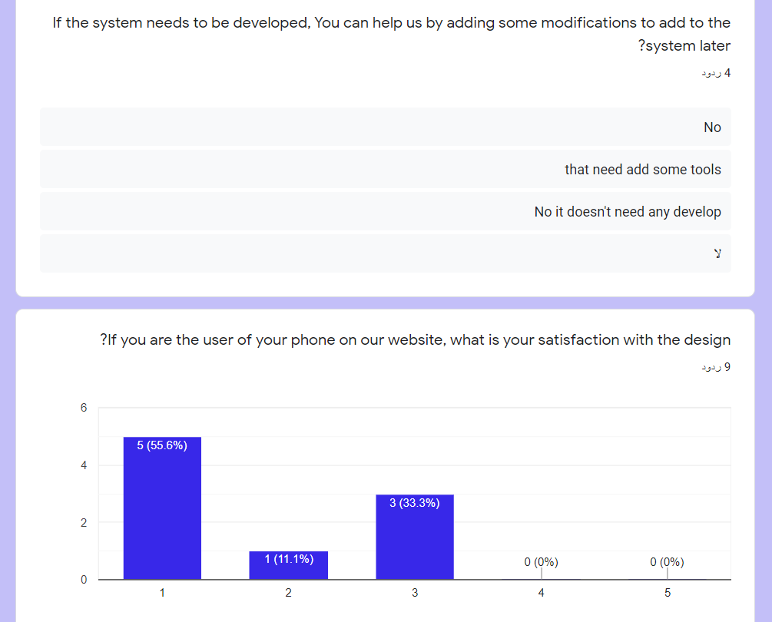

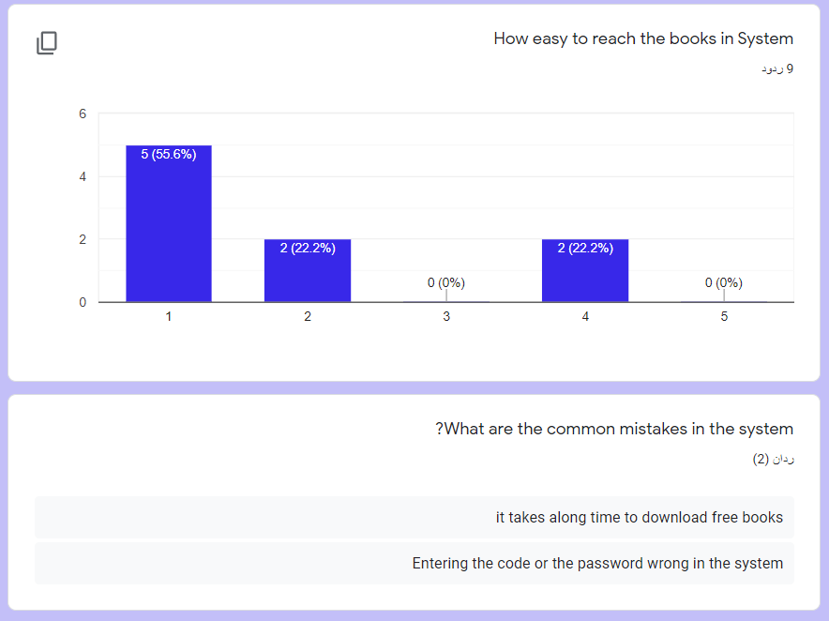
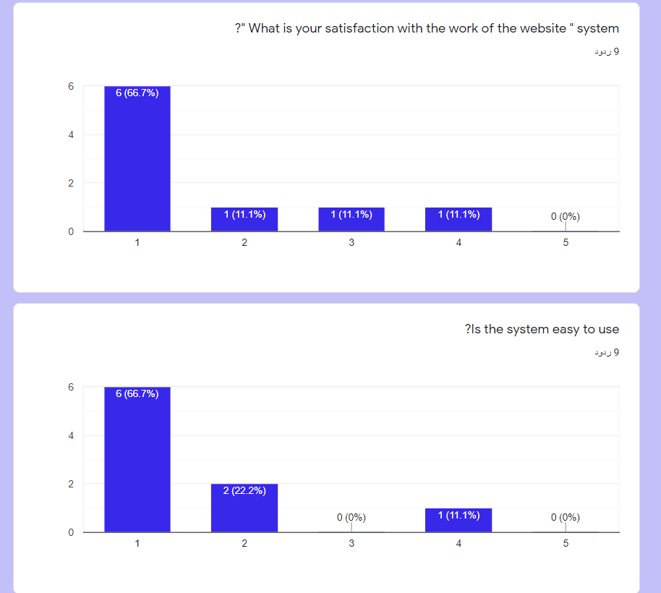

Data Flow Diagram - Context Diagram

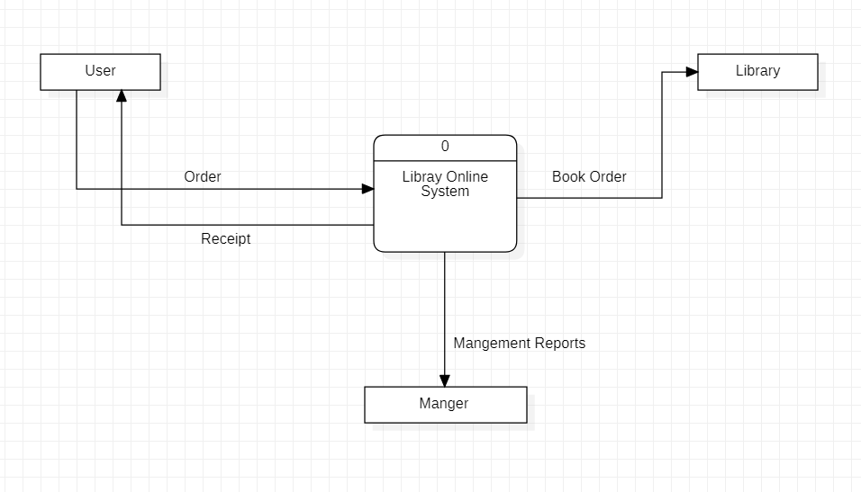

Data Flow Diagram – Level/Diagram 0

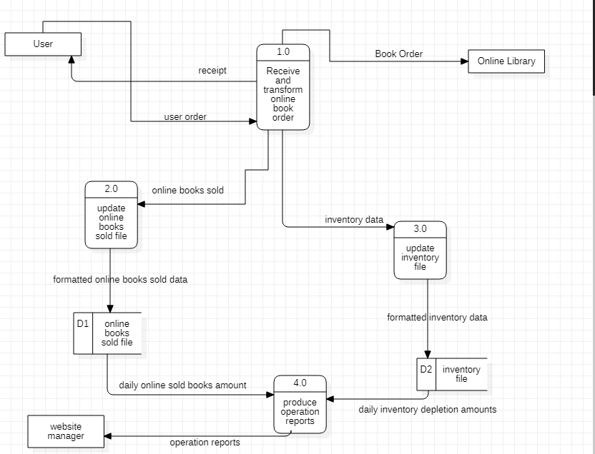

Data Flow Diagram – Level 1

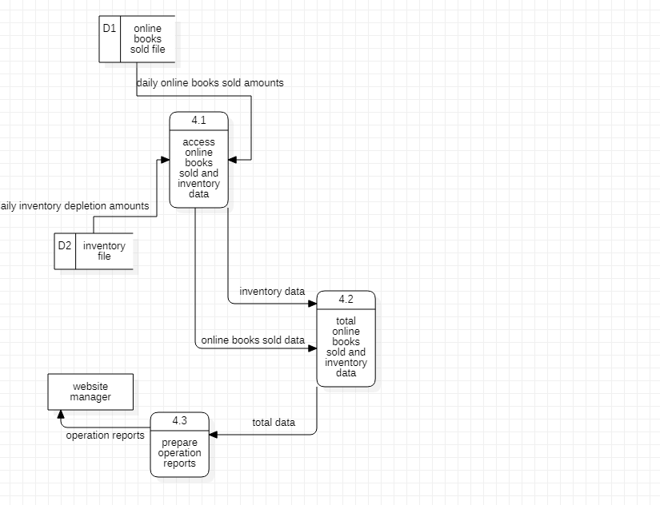
Data Dictionary
DFD: Data Flow
- Description form for Data Flow
Data Flow Description Form
ID: 1
Name (label): user order
Description: contains the customer’s order
Source  External entity - User | Destination  Process 1.0 - receive and transform online book order
Type of Data Flow

File Screen Report Form Internal
Data structure  User data |  | Volume/time  2/hour
comments:

it contains the order of the customer about what the online book he need

Data Flow Description Form
ID: 2
Name (label): receipt
Description: contains the receiving data
Source  Process 1.0 - receive and transform online book order | Destination  External entity - User
Type of Data Flow

File Screen Report Form Internal
Data structure  Receipt data |  | Volume/time  4/hour
comments:

It contains the receiving data mean that the book orders which the customer request from the online library. It will appear a message which says if this book is existing or not.

Data Flow Description Form
ID: 3
Name (label): Book Order
Description: contains the transforming data
Source  Process 1.0 - receive and transform online book order | Destination  External entity – online library
Type of Data Flow

File Screen Report Form Internal
Data structure  Transformation data |  | Volume/time  3/hour
comments:

it contains the transformation data about the book order after receiving it from the user

Data Flow Description Form
ID: 4
Name (label): online books sold
Description: contains the sold information data
Source  Process 1.0 - receive and transform online book order | Destination  Process 2.0 – update online books sold file
Type of Data Flow

File Screen Report Form Internal
Data structure  Sold data |  | Volume/time  8/hour
comments:

it contains the information of the sold books like how many and what the amount, etc.

Data Flow Description Form
ID: 5
Name (label): inventory data
Description: contains information about the inventory
Source  Process 1.0 - receive and transform online book order | Destination  Process 3.0 – update inventory file
Type of Data Flow

File Screen Report Form Internal
Data structure  Inventory data |  | Volume/time  10/hour
comments:

It contains the information about the inventory of the books because it needs to be updated every once the customer buy a book.

Data Flow Description Form
ID: 6
Name (label): formatted online books sold data
Description: contains the formatted sold information
Source  Process 2.0 – update online books sold file | Destination  Data store – online books sold file
Type of Data Flow

File Screen Report Form Internal
Data structure  Formatted sold data |  | Volume/time  9/hour
comments:

it contains the information data about the sold online books after being formatted

Data Flow Description Form
ID: 7
Name (label): formatted inventory data
Description: contains the formatted inventory information
Source  Process 3.0 – update inventory file | Destination  Data store – inventory file
Type of Data Flow

File Screen Report Form Internal
Data structure  Formatted inventory data |  | Volume/time  9/hour
comments:

it contains the formatted information data about the inventory

Data Flow Description Form
ID: 8
Name (label): daily online sold books amount
Description: it contains the daily sold amount
Source  Data store – online books sold file | Destination  Process 4.0 – produce operation reports
Type of Data Flow

File Screen Report Form Internal
Data structure  Sold amount data |  | Volume/time  4/hour
comments:

contains the online sold books amount report which been sold the whole day

Data Flow Description Form
ID: 9
Name (label): daily inventory depletion amount
Description: contains the daily inventory amount
Source  Data store – inventory file | Destination  Process 4.0 – produce operation reports
Type of Data Flow

File Screen Report Form Internal
Data structure  Inventory amount data |  | Volume/time  4/hour
comments:

it contains the information about the daily inventory amount data (the store)

Data Flow Description Form
ID: 10
Name (label): operation reports
Description: contains the final report
Source  Process 4.0 – produce operation reports | Destination  External entity –website manager
Type of Data Flow

File Screen Report Form Internal
Data structure  Report data |  | Volume/time  2/hour
comments:

It contains the final report data after the system of the online books library work the whole day. It will go to the website manager at the end

(2)Data Structure for Data Flow
User = first name + last name + password + phone number + user address + email + credit card number + security code
Receipt = first name + last name + phone number + user address + email + book name
Book order = book name + first name + last name + password + phone number + user address + email + credit card number + security code
Online books sold = book name + sold amount + [profits, losses] + first name + last name + book code + book ID
Inventory data = book name + inventory amount + book code + book ID
Formatted online books sold data = book name + book ID + book code + sold amount + [profits, losses] + first name + last name
Formatted inventory data = book name + inventory amount + book code + book ID
Daily online books sold amount = book name + book ID + book code + sold amount + [profits, losses] + first name + last name + user address + email + (date)
Daily inventory depletion amount = book name + inventory amount + book code + book ID + (date)
Operation reports = first name + last name + phone number + user address + email + book name + sold amount + [profits, losses] + book code + book ID + inventory amount + (date)

- Data Structure for Data Flow: Structural Record
User = first name + last name + password + phone number + user address + email + credit card number + security code
Receipt = first name + last name + phone number + user address + email + book name
Book order = book name + first name + last name + password + phone number + user address + email + credit card number + security code
Online books sold = book name + sold amount + [profits, losses] + first name + last name + book code + book ID
Inventory data = book name + inventory amount + book code + book ID
Formatted online books sold data = book name + book ID + book code + sold amount + [profits, losses] + first name + last name
Formatted inventory data = book name + inventory amount + book code + book ID
Daily online books sold amount = book name + book ID + book code + sold amount + [profits, losses] + first name + last name + user address + email + (date)
Daily inventory depletion amount = book name + inventory amount + book code + book ID + (date)
Operation reports = first name + last name + phone number + user address + email + book name + sold amount + [profits, losses] + book code + book ID + inventory amount + (date)
- Data Element for data flow
 | ID
First name | Name
Customer first name | Alias
Contains the customer`s first name | Description
20 | Length
X(20) | Input Format
X(20) | Output Format
 | Default Value
Discrete | Continuous / Discrete
Alphabetic | Type
Base | Base / Derived
 | Upper Limit
 | Lower Limit
 | Discrete
Every customer has a first name | Comments

 | ID
Second name | Name
Customer second name | Alias
Contains the customer`s second name | Description
20 | Length
X(20) | Input Format
X(20) | Output Format
 | Default Value
Discrete | Continuous / Discrete
Alphabetic | Type
Base | Base / Derived
 | Upper Limit
 | Lower Limit
 | Discrete
Every customer has a second name | Comments

 | ID
Password | Name
Customer password | Alias
Contains the customer`s password | Description
10 | Length
9(10) | Input Format
9(10) | Output Format
 | Default Value
Continuous | Continuous / Discrete
Number | Type
Derived | Base / Derived
 | Upper Limit
 | Lower Limit
 | Discrete
Every customer should have a password | Comments

 | ID
Phone number | Name
Customer phone number | Alias
Contains the customer`s phone number | Description
15 | Length
9(15) | Input Format
9(15) | Output Format
 | Default Value
Continuous | Continuous / Discrete
Number | Type
Derived | Base / Derived
 | Upper Limit
 | Lower Limit
 | Discrete
Every customer should have a phone number | Comments

 | ID
User address | Name
Customer address | Alias
Contains the customer`s address | Description
30 | Length
X(30) | Input Format
X(30) | Output Format
 | Default Value
Discrete | Continuous / Discrete
Alphabet | Type
Base | Base / Derived
 | Upper Limit
 | Lower Limit
 | Discrete
Every customer should have an address | Comments

 | ID
Email | Name
Customer email | Alias
Contains the customer`s email | Description
40 | Length
X(40) | Input Format
X(40) | Output Format
 | Default Value
Discrete | Continuous / Discrete
Alphabet | Type
Base | Base / Derived
 | Upper Limit
 | Lower Limit
 | Discrete
Every customer should have address | Comments

 | ID
Credit card number | Name
Customer credit card | Alias
Contains the customer`s credit card number or code | Description
20 | Length
9(20) | Input Format
9(20) | Output Format
 | Default Value
Continuous | Continuous / Discrete
Number | Type
Derived | Base / Derived
 | Upper Limit
 | Lower Limit
 | Discrete
Every customer should have a credit card | Comments

 | ID
Security code | Name
Customer security code | Alias
Contains the customer`s security code | Description
30 | Length
9(30) | Input Format
9(30) | Output Format
 | Default Value
Continuous | Continuous / Discrete
Number | Type
Derived | Base / Derived
 | Upper Limit
 | Lower Limit
 | Discrete
Every customer should have a security code to keep his information safe | Comments

 | ID
Book name | Name
Book`s name | Alias
Contains the book`s name | Description
25 | Length
X(25) | Input Format
X(25) | Output Format
 | Default Value
Discrete | Continuous / Discrete
Alphabet | Type
Base | Base / Derived
 | Upper Limit
 | Lower Limit
 | Discrete
Every book should have a name | Comments

 | ID
Sold amount | Name
Number of sold amount | Alias
Contains the number of the sold amount | Description
10 | Length
9(10) | Input Format
9(10) | Output Format
 | Default Value
Continuous | Continuous / Discrete
Number | Type
Derived | Base / Derived
 | Upper Limit
 | Lower Limit
 | Discrete
The sold amount is important to know daily | Comments

 | ID
[profits, losses] | Name
Profits or losses | Alias
Contains the number of the profits or the losses | Description
10 | Length
9(10) | Input Format
9(10) | Output Format
 | Default Value
Continuous | Continuous / Discrete
Number | Type
Derived | Base / Derived
 | Upper Limit
 | Lower Limit
 | Discrete
We should always know the number of the profits or the losses | Comments

 | ID
Book code | Name
Book code | Alias
Contains the book`s code | Description
20 | Length
9(20) | Input Format
9(20) | Output Format
 | Default Value
Continuous | Continuous / Discrete
Number | Type
Derived | Base / Derived
 | Upper Limit
 | Lower Limit
 | Discrete
The book should have a code | Comments

 | ID
Book ID | Name
Book ID | Alias
Contains the book`s ID | Description
20 | Length
9(20) | Input Format
9(20) | Output Format
 | Default Value
Continuous | Continuous / Discrete
Number | Type
Derived | Base / Derived
 | Upper Limit
 | Lower Limit
 | Discrete
The book should have an ID | Comments

 | ID
Inventory amount | Name
Inventory amount | Alias
Contains the inventory`s amount | Description
15 | Length
9(15) | Input Format
9(15) | Output Format
 | Default Value
Continuous | Continuous / Discrete
Number | Type
Derived | Base / Derived
 | Upper Limit
 | Lower Limit
 | Discrete
Every day the inventory will be updated | Comments

 | ID
(date) | Name
Date | Alias
Contains the operation`s date | Description
20 | Length
9(20) | Input Format
9(20) | Output Format
 | Default Value
Continuous | Continuous / Discrete
Number | Type
Derived | Base / Derived
 | Upper Limit
 | Lower Limit
 | Discrete
The date of every operation is an optional element | Comments

DFD: Data Store
 | ID
Online books sold file | Name
Sold file | Alias
Contains the sold file | Description
Database | File Type
 | File Format
20 | Record Size
40 | Maximum Records
30 | Average Records
4/year | Growth per Year
 | Data Set
Store data | Data Structure
 | Primary Key
 | Secondary Key
The sold amount should be stored daily | Comments

 | ID
Inventory file | Name
Inventory file | Alias
Contains the inventory file | Description
Database | File Type
 | File Format
20 | Record Size
40 | Maximum Records
30 | Average Records
4/year | Growth per Year
 | Data Set
Store data | Data Structure
 | Primary Key
 | Secondary Key
The inventory amount are being updated daily so that it should be stored daily | Comments

Process Specification
- Note: apply process specification for all project processes

Process Specification Form
Number: 1.o
Name: Receive and transform order
Description: This process use to receive and transform the user order
Input Data Flow
The user order from External Entity
Output Data Flow
Send the order to the online library and receipt the order
Type of Process
Online Batch Manual
Process Logic:
IF customer is preferred customer, then
If Customer order more than 1000$ then
Apply a 5% discount
If Customer use char card
Apply an additional 5% discount then
End if
Award 25$ bonus coupon
End if
Else Award 5$ bonus coupon
End if
Structured English Decision Table Decision Tree
Unresolved Issues:
Process Specification Form
Number: 2.o
Name: update online books sold file
Description: this process receive the update of online Sold Books and store the update in the online books Sold file
Input Data Flow :
the online sold books
Output Data Flow
Formatted online books sold file
Type of Process
Online Batch Manual
Process Logic:
 |  | 1 | 2 | 3 | 4 | 5 | 6 | 7 | 8
1 | Lack of books | Y | Y | Y | Y | N | N | N | N
2 | New book release | Y | Y | N | N | Y | Y | N | N
3 | Laggy server | Y | N | Y | N | Y | N | Y | N

1 | New update | X | X | X | X
2 | Add the new version | X | X |  |  | X | X
3 | New features | X |  | X |  | X |  | X
4 | Weekly update |  |  |  |  |  |  |  | X

Structured English Decision Table Decision Tree
Unresolved Issues:

Process Specification Form
Number: 3.o
Name: update inventory file
Description: this process receive the inventory data ,update it and formatted it into inventory file
Input Data Flow : inventory data
inventory data
Output Data Flow :
Formatted inventory data
Type of Process
Online Batch Manual
Process Logic:

 |  | 1 | 2 | 3 | 4 | 5 | 6 | 7 | 8
1 | Lack of quantity | Y | Y | Y | Y | N | N | N | N
2 | The order is greater than quantity | Y | Y | N | N | Y | Y | N | N
3 | The quantity is not knowing | Y | N | Y | N | Y | N | Y | N

1 | Update a new stock | X | X | X | X
2 | Move order to backordered record | X | X |  |  | X | X
3 | Do quantity inventory | X |  | X |  | X |  | X
4 | Weekly inventory |  |  |  |  |  |  |  | X

Structured English Decision Table Decision Tree
Unresolved Issues:

Process Specification Form
Number: 4.o
Name: produce operation reports
Description: this process receive the daily inventory depletion amounts and the daily online sold books amounts and do operation report and send it to the website manager
Input Data Flow :
daily online sold books amounts and inventory depletion amounts
Output Data Flow
The operation report
Type of Process
Online Batch Manual
Process Logic:

Routine update
2

Lack of books
Call the its unit to fix the error
3

Errors in the system
1
New features
4
Laggy server

Preferred customer Do discount
5

Structured English Decision Table Decision Tree
Unresolved Issues:

Normalization
Normal Tables
id | Name | email | Book id | price | Payment type | Publisher id | Publisher name | address
1 | ahmed | Ah12@gmail.com | 3 | 16$ | visa | 2 | Hassan | Cairo
2 | ali | Al12@gmail.com | 3 | 16$ | visa | 3 | Osama | Giza
3 | rawan | ra12@gmail.com | 4 | 20$ | visa | 1 | Mohamed | Aswan
1 | ahmed | Ah12@gmail.com | 4 | 10$ | cash | 3 | Osama | Giza
3 | rawan | ra12@gmail.com | 2 | 10$ | cash | 2 | Hassan | Cairo
4 | joulnar | jo18@gmail.com | 4 | 20$ | visa | 4 | Jone | USA
2 | ali | Al12@gmail.com | 3 | 16$ | visa | 1 | Mohamed | Aswan

Tables after 1NF
id | Name | email
1 | ahmed | Ah12@gmail.com
2 | Ali | Al12@gmail.com
3 | Rawan | ra12@gmail.com
4 | joulnar | jo18@gmail.com

id | Book id | price | Payment type | Publisher id | Publisher name | address
1 | 3 | 16$ | visa | 2 | Hassan | Cairo
2 | 3 | 16$ | visa | 3 | Osama | Giza
3 | 4 | 20$ | visa | 1 | Mohamed | Aswan
1 | 4 | 10$ | cash | 3 | Osama | Giza
3 | 2 | 10$ | cash | 2 | Hassan | Cairo
4 | 4 | 20$ | visa | 4 | Jone | USA
2 | 3 | 16$ | visa | 1 | Mohamed | Aswan

Tables after 2NF
id | Name | email
1 | ahmed | Ah12@gmail.com
2 | Ali | Al12@gmail.com
3 | Rawan | ra12@gmail.com
4 | joulnar | jo18@gmail.com

Publisher id | Publisher name | address
2 | Hassan | Cairo
3 | Osama | Giza
1 | Mohamed | Aswan
4 | Jone | USA

id | Publisher id | Book id | price | Payment type
1 | 2 | 3 | 16$ | visa
2 | 3 | 3 | 16$ | visa
3 | 1 | 4 | 20$ | visa
1 | 3 | 4 | 10$ | cash
3 | 2 | 2 | 10$ | cash
4 | 4 | 4 | 20$ | visa
2 | 1 | 3 | 16$ | visa

Tables after 3NF
id | Name | email
1 | ahmed | Ah12@gmail.com
2 | Ali | Al12@gmail.com
3 | Rawan | ra12@gmail.com
4 | joulnar | jo18@gmail.com

Publisher id | Publisher name | address
2 | Hassan | Cairo
3 | Osama | Giza
1 | Mohamed | Aswan
4 | Jone | USA

id | Publisher id | Book id | price | Payment type
1 | 2 | 3 | 16$ | visa
2 | 3 | 3 | 16$ | visa
3 | 1 | 4 | 20$ | visa
1 | 3 | 4 | 10$ | cash
3 | 2 | 2 | 10$ | cash
4 | 4 | 4 | 20$ | visa
2 | 1 | 3 | 16$ | visa

Entity Relationship Diagram (ERD)

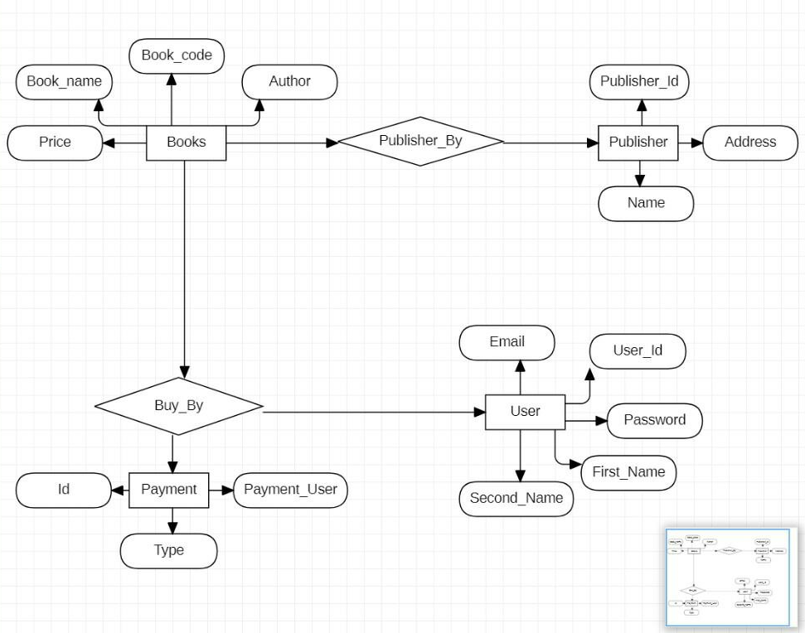
UML – Use Case
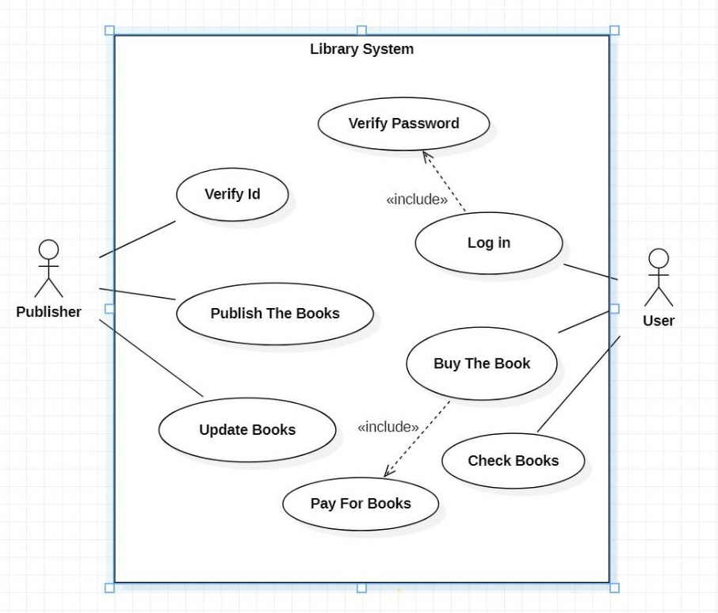
UML – Class Diagram
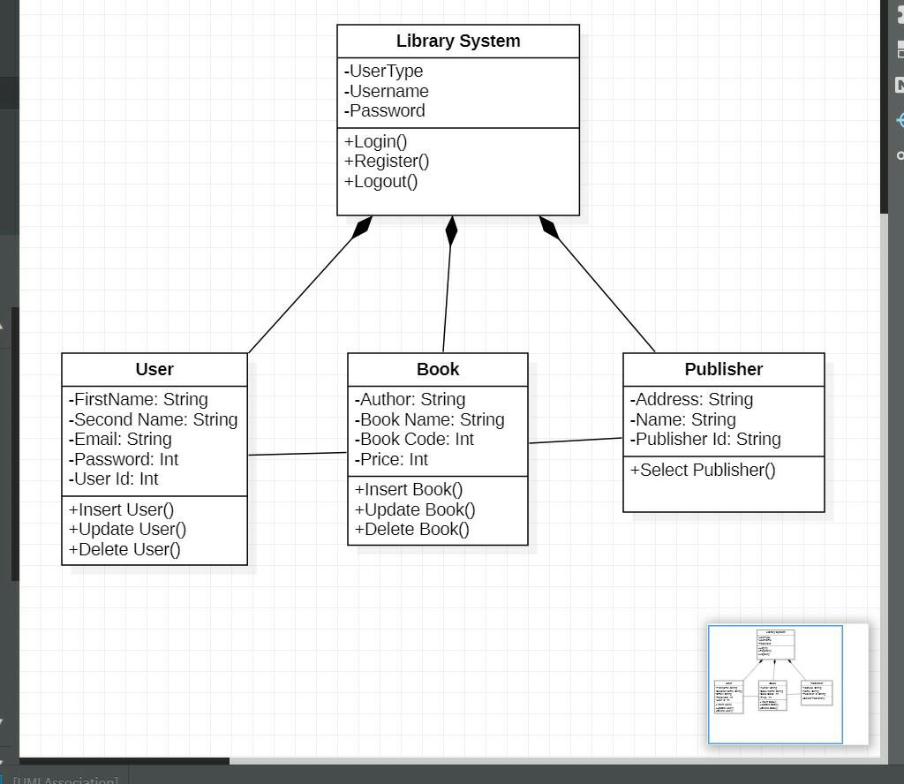
UML – Sequence Diagram
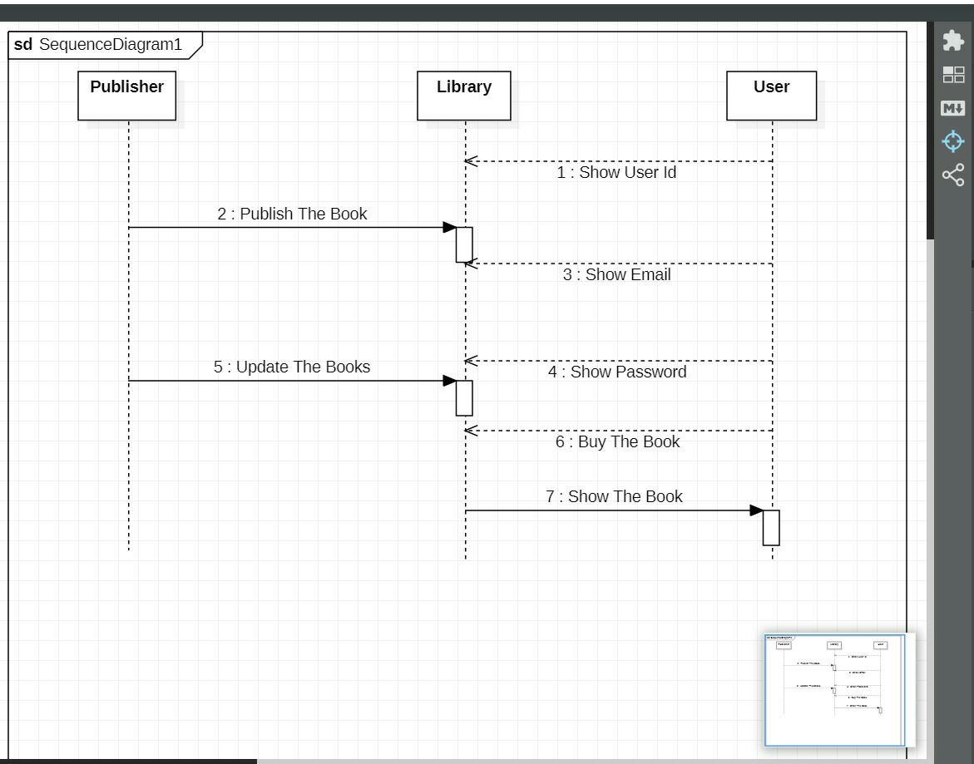

Design (Project Specification)
[A] Architecture Design
    - Operational Requirements
Requirement
Technical Environment
System Integration
Portability
Maintainability

2. Performance Requirements
Requirement
Speed
Capacity
Availability and reliability

3. Security Requirements
Requirement
System value estimates
Access control
Encryption and authentication
Virus control

[2] Data storage Design

1. Data storage format:

2. Convert logical ERD to physical ERD:

[3] Program design
- Convert logical DFD to physical DFD:

[4] Interface design
1. Use Scenario Development

2. Interface Structure Design

3. Interface Standards Design
(1) Interface Metaphor

(2) Interface Template

4. Interface Design Prototyping
Implementation (New System)
PROJECT MANAGEMENT & SCHEDULE PLAN
Complete Task Schedule, Timeline Header & Gantt Chart View

1. Task Details & Predecessors Table
ID | Task Name | Start Date | Finish Date | Duration | Predecessors
1 | Planning | 09/11/2020 | 19/11/2020 | 11 days | -
2 | System Request | 09/11/2020 | 12/11/2020 | 4 days | 1
3 | Feasibility Study | 12/11/2020 | 17/11/2020 | 4 days | 2
4 | Pert Chart | 17/11/2020 | 19/11/2020 | 3 days | 3
5 | Grantt Chart | 17/11/2020 | 19/11/2020 | 3 days | 3
6 | Analysis | 19/11/2020 | 06/12/2020 | 16 days | 1
7 | Interview | 19/11/2020 | 24/11/2020 | 4 days | 6
8 | Questionnaire | 19/11/2020 | 23/11/2020 | 3 days | 7
9 | Data Flow Diagram | 24/11/2020 | 29/11/2020 | 5 days | 7
10 | Data Store | 29/11/2020 | 02/12/2020 | 3 days | 9
11 | Process Specification | 29/11/2020 | 03/12/2020 | 4 days | 9
12 | Entity Relationship | 02/12/2020 | 06/12/2020 | 4 days | 10
13 | Normalization | 02/12/2020 | 06/12/2020 | 3 days | 10
14 | Design | 07/12/2020 | 02/01/2021 | 25 days | 6
15 | Data base | 07/12/2020 | 14/12/2020 | 7 days | 12, 13
16 | Code | 14/12/2020 | 02/01/2021 | 18 days | 15
17 | Implementation | 02/01/2021 | 24/01/2021 | 22 days | 14
18 | Implementation (Sub-task) | 02/01/2021 | 24/01/2021 | 22 days | 16

2. Gantt Chart Diagram (With Exact Dates Header)
Visual representation of tasks mapped against dates timeline across Nov 2020 - Jan 2021:
Task Name / ID | 07/11/20 | 14/11/20 | 21/11/20 | 28/11/20 | 05/12/20 | 12/12/20 | 19/12/20 | 26/12/20 | 02/01/21 | 09/01/21 | 16/01/21 | 23/01/21
1. Planning | ███
2. System Request | ███
3. Feasibility Study | ███
4. Pert Chart |  | ███
5. Grantt Chart |  | ███
6. Analysis |  |  | ███ | ███
7. Interview |  |  | ███
8. Questionnaire |  |  | ███
9. Data Flow Diagram |  |  | ███ | ███
10. Data Store |  |  |  | ███
11. Process Spec. |  |  |  | ███
12. Entity Relationship |  |  |  | ███ | ███
13. Normalization |  |  |  | ███ | ███
14. Design |  |  |  |  | ███ | ███ | ███
15. Data base |  |  |  |  | ███ | ███
16. Code |  |  |  |  |  | ███ | ███
17. Implementation |  |  |  |  |  |  |  |  | ███ | ███ | ███ | ███
18. Sub-Implementation |  |  |  |  |  |  |  |  | ███ | ███ | ███ | ███
Entire Project Bar | ███ | ███ | ███ | ███ | ███ | ███ | ███ | ███ | ███ | ███ | ███ | ███

SYSTEM ANALYSIS & DESIGN PROJECT
INTERVIEW REPORT
Project: Expense Tracker System
Interview Report | Expense Tracker System - Requirements Gathering
Person Interviewed: | Seif Abdelhakeem
Interviewer: | Mohamed Hussein
Purpose of Interview: | 1. To understand the current problems faced in manual personal expense tracking.  2. To determine essential expense categories and monthly budget limits.  3. To define key user requirements and features for the Expense Tracker web application.
Summary of Interview: | • The interviewee currently tracks daily expenses manually using phone notes, frequently forgetting small transactions.  • Facing difficulty analyzing monthly spending and understanding where salary/budget is spent across categories (e.g., food, transportation, bills).  • Requires a simple web application accessible via mobile phones with quick transaction entry (taking less than 1 minute).  • Emphasized the need for monthly category budgets, automated warning notifications when reaching budget thresholds (80% and 100%), visual dashboard charts, and secure user login.
Open Items: | 1. Design a mobile-responsive dashboard interface for fast expense entry.  2. Implement automated notification alerts when approaching category budget limits.  3. Add recurring expense reminders and report export capabilities (PDF/CSV).
Detailed Notes: | See attached transcript.

Detailed Interview Questions & Answers Transcript
Q: How do you currently record and track your daily expenses?
A: I usually write some expenses in my phone notes, but I sometimes forget to record small purchases.
Q: What are the biggest problems you face when managing your money?
A: It is difficult to remember where my money went and to understand which categories cost me the most.
Q: Which expense categories would be most useful for you to track?
A: Food, transportation, bills, shopping, education, and entertainment.
Q: What reports or summaries would help you understand your spending?
A: A monthly summary, category totals, and a comparison between this month and last month.
Q: What features would make an expense tracker easy and useful for you?
A: Quick expense entry, a simple interface, search and filtering, budgets, and reminders.
Q: Would you like the system to let you set a monthly budget?
A: Yes.
Q: Would you use the system regularly if adding an expense took less than a minute?
A: Yes.
Q: What is the main reason you want to use an expense tracker?
A: I want to control my spending and avoid running out of money before the end of the month.
Q: Would you like to receive a warning when you approach your budget limit?
A: Yes.
Q: Which device would you mainly use?
A: Mobile phone.

